00c - Sprint Plan - Sprint 3

Part 1: Sprint Info & Task Management board

Team number: 12
Sprint Number: 3 | Sprint Duration (Start – End Dates): May 18 - May 22
Task Manager Platform Link here (Clickable and Public) :
https://trello.com/invite/b/69f1252414c3094e343d62fe/ATTI08c02146cbf06f985e835fed3d7d8b55340072F9/-
Task Coordinator name here :
Jonah Botelho

Part 2: Sprint Plan

Sprint Goal(s)

Perform a regression test on our app and finish our final presentation.

Outcomes
Outcome | Answer to “So What?”
Regression test is done | So we know there is nothing broken with our app
Video for client | So they have a demonstration for their team when they receive our code in the handoff
Final presentation is done | So we have something to present to our supervisor and client

Deliverables

Deliverables | Show me
FInal presentation | Live presentation on May 21, and power point slides
Demo video for client | Video

Tasks
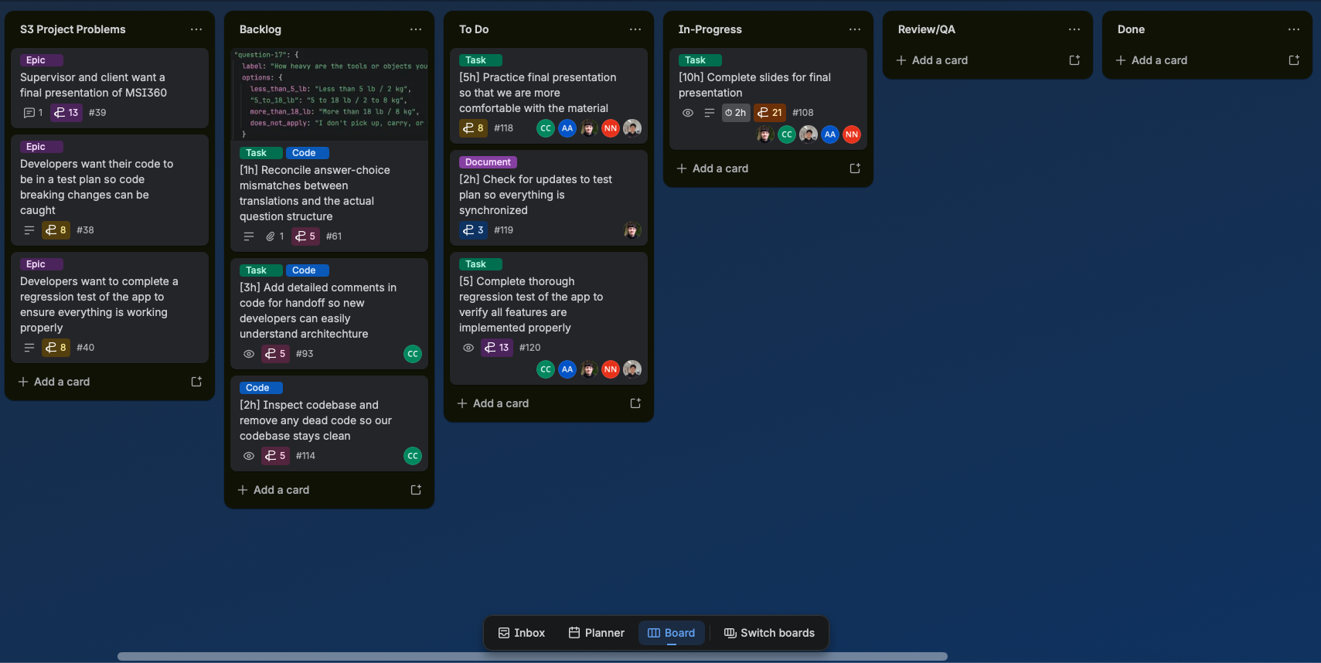

Risks and Issues
Risk ID + Related Task ID(s) | Risk or Issue Description | Potential Impact | Mitigation/Resolution Steps | Status
#118 | Our client may give last minute requests after our presentation demo on Tuesday | We may need to quickly implement these changes or deny the request based on the difficulty and time frame | Quickly change any requests they have on Wednesday before the final presentation | Open

